SHAISHAV KAYASTHA
IIM Ahmedabad Alumni | Business Head | Public Speaker
  Address: | A-5, Sangath Bungalows – I, Near Motera Stadium, Motera Road, Sabarmati, Ahmedabad – 380005, Gujarat, India.
Mobile / Email: | +91 90999 21767 | ✉️ shaishav.kayastha@gmail.com

PROFILE SUMMARY
- Strategic and performance-driven business leader with over 17 years of expertise, managing teams and regions with 120+ Team Members.
- Marketing, Sales, P&L Ownership, Business Operations, and Organizational Leadership within the Education and Service industries.
- Proven track record in transforming underperforming regions into top-performing zones through innovative strategies, team development, and customer engagement.
- Recognized for building strong teams, delivering record-breaking revenues, and revolutionizing EdTech practices across Western India.
- Adept at designing and executing high-impact marketing campaigns, corporate relations programs, and training initiatives for diverse stakeholders.
CORE COMPETENCIES
- Strategic Planning & Execution
- Business Development & Expansion
- P&L Management & Forecasting
- Marketing & Brand Communication
- Channel Sales & Institutional Partnerships
- ATL & BTL Campaign Management
- Team Leadership & Training Delivery
- Customer Engagement & Relationship Management
PROFESSIONAL EXPERIENCE
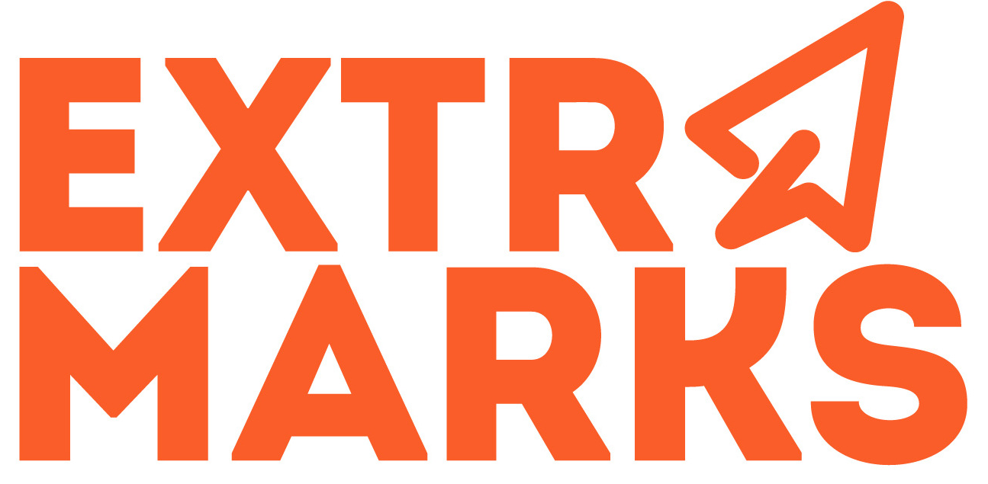
Extramarks Education India Pvt. Ltd. | Gujarat, Maharashtra, Goa & Rajasthan | May 2010 – April 2025
Business Head – Western India
- Lead a 120+ member team across sales, training, marketing, and service functions.
- Designed and executed Retail, Institutional, and Corporate Sales Strategies.
- Delivered over 7,00,000 teacher trainings pan-India on transforming education and digital learning techniques.
- Developed Marketing Communication materials and handled end-to-end ATL & BTL campaigns.
- Enhanced regional revenue to ₹150+ Cr over 15 years through data-driven planning and execution.
- Contributed to Extramarks becoming the No. 1 EdTech company in Gujarat since 2012.
- Key Achievements
- The Times of India awarded “Men of the Year” (2018 & 2019)
- Extramarks National awards for Best Business Head, Best Revenue Generation, and Best Team Lead.
- Successfully implemented go-to-market plans generating ₹74 Cr in cash in bank revenue
- Created a 100% advance payment model for Gujarat territory and a model replicated for Indian Market.
Executive – Marketing & Corporate Relations
Xcellon Education Ltd. (Claris Lifesciences) | Ahmedabad | Dec 2008 – May 2010
- Managed marketing campaigns, corporate events, and strategic partnerships.
- Spearheaded ATL & BTL activities with cross-functional creative teams.
- Addressed public gatherings and led team training on sales and business development.
- Worked on Developing Organization from scratch
Marketing & Corporate Relations Executive
Kuoni Travel Group (SOTC) | Ahmedabad | Jan 2008 – Dec 2008
Customer Care Executive / Team Lead
I-Call India Ltd. (Adani Group) | Ahmedabad | Apr 2004 – Dec 2004
EDUCATION
Institution | Year | Course
The Indian Institute of Management, Ahmedabad – IIM A | 2019 - 2020 | Advanced General Management Program
The Indian Institute of Planning and Management, Ahmedabad – IIPM | 2006 - 2008 | PGP – Planning & Entrepreneurship
IMI Belgium (Europe) | 2006 - 2008 | MBA – Marketing & Entrepreneurship
Gujarat University | 2003 - 2006 | B.Com.

INTERNATIONAL PROJECTS & THESIS

Georgetown University, USA – Comparative Study: Indian Secondary Education vs Global Models

United Nations HQ, New York – Participated in sessions on international development and world peace

World Bank, Washington DC – Research on Indian economic growth & global positioning

New York Mercantile Exchange (NYMEX), New York – Study on global commodity exchange

Thesis – Status of Secondary Education in India and Road Ahead (2008)

ADDITIONAL ENGAGEMENTS
- Guest Radio Jockey & Voiceover Artist – Radio One FM 95 & 93.5 S FM
- Visiting Faculty – Various premier business schools in India
- Social Media Influencer & Motivational Public Speaker
PERSONAL DETAILS
Date of Birth: 17th April 1986
Languages: English, Hindi, Gujarati

Digital Presence
 | Shaishav Kayastha | 5514 + Followers
 | Shaishav.edupreneur | 23K + Followers
 | Shaishav Kayastha | 2750 + Followers
 | Shaishav Kayastha | 667 + Followers

